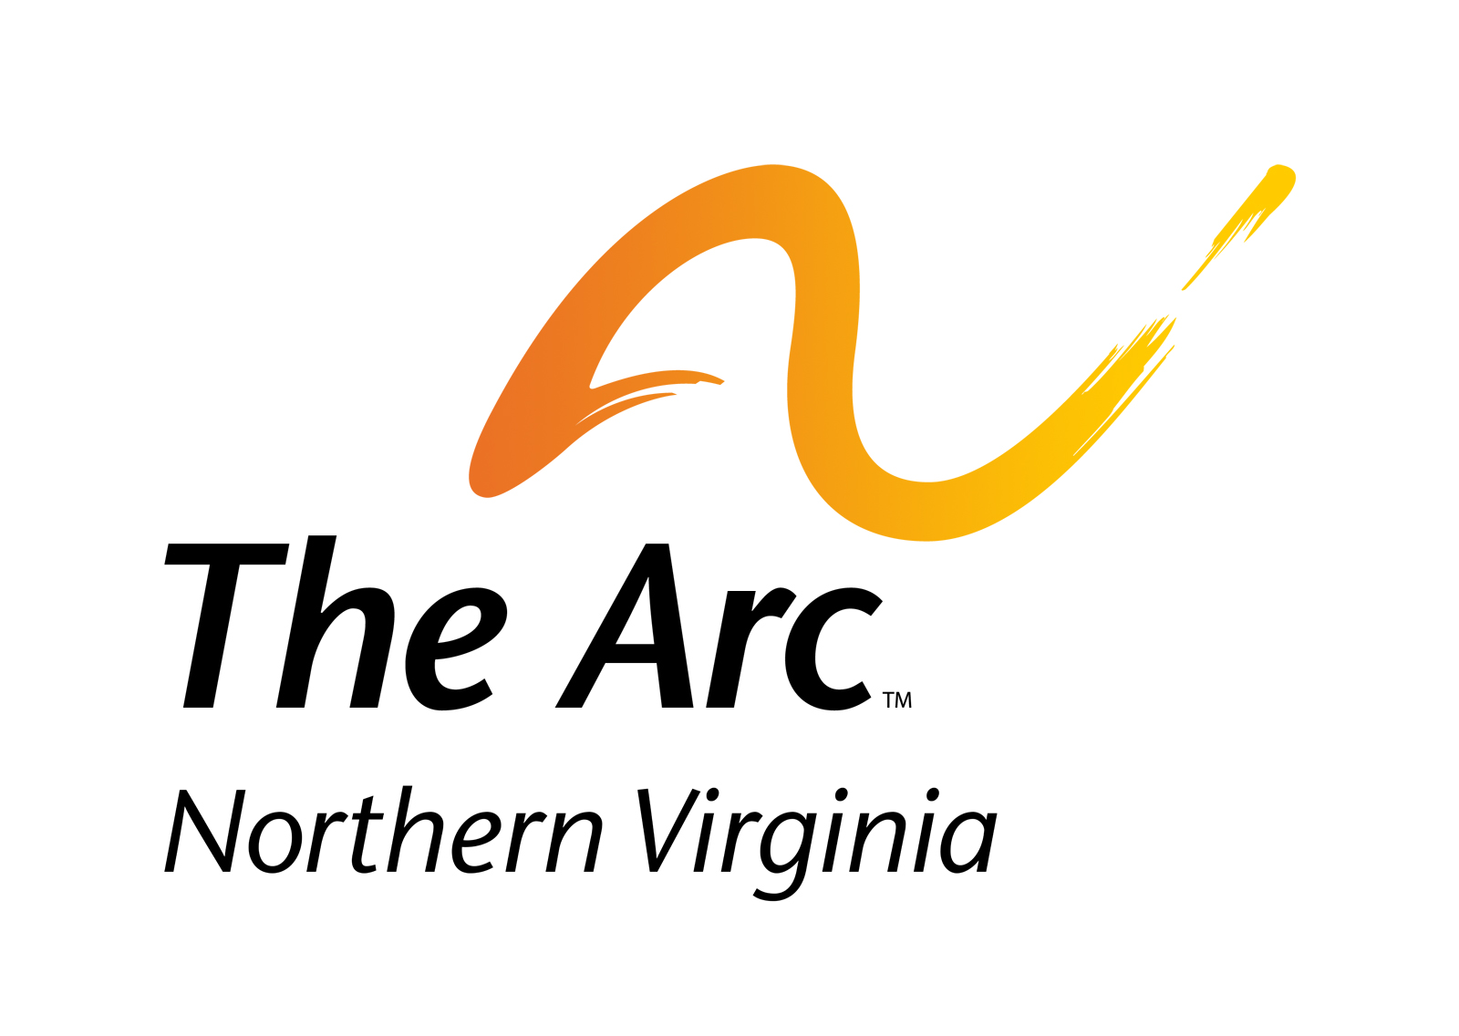
The Arc of Northern Virginia
2755 Hartland Road, Suite 200
Falls Church, VA 22043

T 703-208-1119
F 703-208-0906
www.thearcofnova.org

Achieve with us

[Date]

[Name]
[Title]
[Company]
[Address]
[City/State/ZIP]

Dear [Name}:

The Arc of Northern Virginia is a community nonprofit that provides direct services, education and advocacy for people with intellectual and developmental disabilities and their families. There are an estimated 34,000 people with ID/DD in Northern Virginia. I am proud to serve as a board member.

I am writing to ask for your support of an exciting event this year. We will hold “A Motown Experience” Gala, our signature fundraiser, on Saturday, October 22, 2016. The Gala will gather 300 people, including our key donors and supporters, as well as local and state legislators and members of the business community.

The evening will feature both a live and silent auction. It would wonderful to offer our attendees the chance to take home an exciting item or experience from your business. We would be grateful if you could donate one or more gift certificates, gift baskets, or items for our auction at the Gala.

Your support would be greatly appreciated and would provide your business with significant exposure. Our members and supporters come from the entire Northern Virginia area and this would be a great opportunity to showcase your business’ products or services, as well as demonstrate your support of the essential work that our organization does.

In recognition of your contribution, The Arc of Northern Virginia will recognize you during the auction, in a special section in the evening’s program, in our ReSources e-newsletter that is sent to more than 2,700 people, on Facebook and LinkedIn, and on our website.
Our Gala raises critically needed funds so The Arc of Northern Virginia can continue to provide our programs and services to people with disabilities and their families. With your help, we can further these vital resources to help people with disabilities be an integral part of our community. (You can read more about how we are improving lives on the reverse of this letter.)

Thank you for your consideration of this request. If you have any questions or would like additional information, you can contact Howard Stregack at 703-208-1119 ext. 102. With your support, we can continue to serve the needs of individuals with intellectual and developmental disabilities and their families in Northern Virginia. Together, we can make an important difference.

Sincerely,

[Name]
Board Member, The Arc of Northern Virginia
About The Arc of Northern Virginia’s Programs and Services

The Arc of Northern Virginia is a 54-year old local nonprofit that represents and serves people with intellectual and developmental disabilities (ID/DD)—including autism, Down syndrome, cerebral palsy, epilepsy, and rare chromosomal disorders—and their families throughout Northern Virginia. It is estimated that more than 34,000 individuals in Northern Virginia have ID/DD.

Information & Referral: The Arc of Northern Virginia fields more than 5,000 information & referral requests each year, helping address time-sensitive issues and solve difficult challenges.

Education: We provide over 30 educational workshops each year on a wide range of topics, such as special needs trusts, guardianship and other alternatives, Medicaid waivers, travel training, housing options, employment opportunities, Social Security benefits, and much more.

Advocacy: We work with our constituents and their families to help them become more effective advocates for better funding and services for people with ID/DD.

Self-Advocacy: The Arc of Northern Virginia provides opportunities for individuals with disabilities to get together in a supportive environment and learn to advocate effectively for their own needs.

Special Needs Trust Management: The Arc of Northern Virginia offers a Special Needs Trust program that allows individuals to receive financial support to enhance their lives without jeopardizing their public benefits (such as SSI and Medicaid) while planning to meet lifetime needs.

Direct Services and Case Management: We provide case management for recipients of the state-funded Developmental Disability Medicaid Waiver to manage the services they receive.

Guardianship: We operate a Guardianship of Last Resort program, serving individuals with developmental disabilities, mental health concerns, and age-related impairments, who have no one else to help with important decisions.

Innovation: We are continually creating new programs in recognition of the changing landscape of public services and in response to family inquiries.

Recent Recognition of our Work

- Our TravelMate and EmployMate “apps” were awarded a Technology Innovation Award from 501cTECH as the 2015 winner of the "Skills to Succeed and Workforce Development Award"
- These cutting-edge projects also brought recognition as 2016 Public Service Innovator of the Year by the Northern Virginia Chamber of Commerce at its Greater Washington Innovation Awards.
- TravelMate was highlighted by the President’s Committee for People with Intellectual Disabilities in their 2015 Report submitted to President Obama. (see a video about it: tinyurl.com/TravMate)
- The Arc of Northern Virginia was recognized by the Falls Church Chamber of Commerce with the 2016 Carroll V. Shreve Award for Meritorious Human Service for our work benefitting the community.
- And we were recently nominated as Non-Profit of the Year for the upcoming Northern Virginia Chamber of Commerce’s 2016 Outstanding Corporate Citizenship Awards.

For additional information, please visit www.TheArcofNoVA.org.

